Practical no 1

AIM: Implement Breadth first search algorithm for Romanian map problem or any other map
Code:

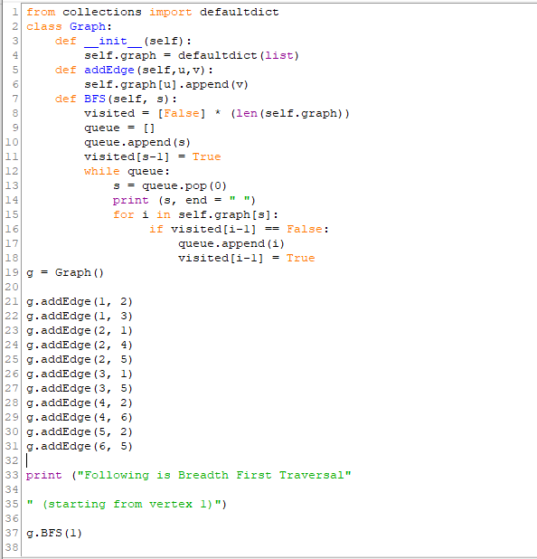

output:

